SMMS Schedule 05/05/26 Susie and Lucy
This table shows how many pharmacists are needed at each time (30 minute increments)
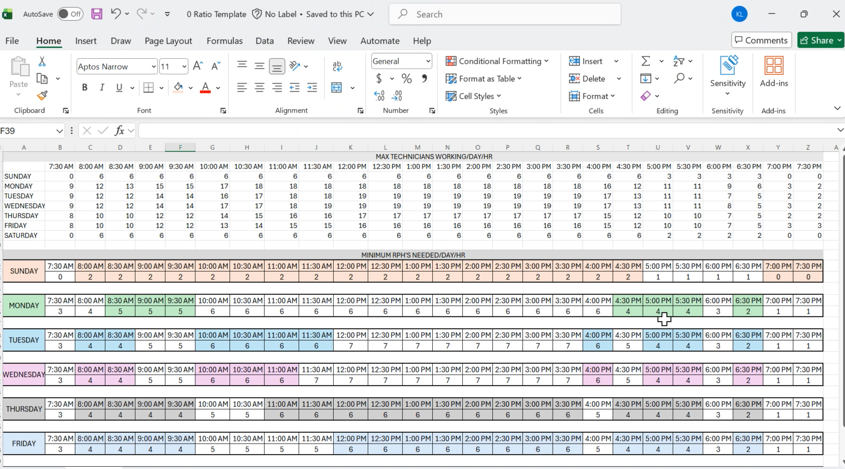

Only count functioning tech for ratio (not management)
In when I work:
Log in: dr.monahan@yahoo.com
Password: Courtneyann2026!
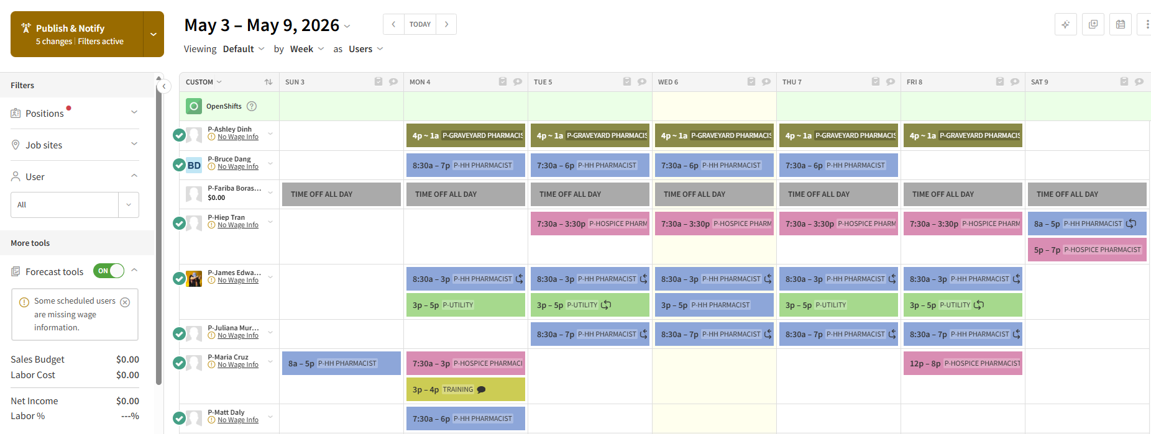
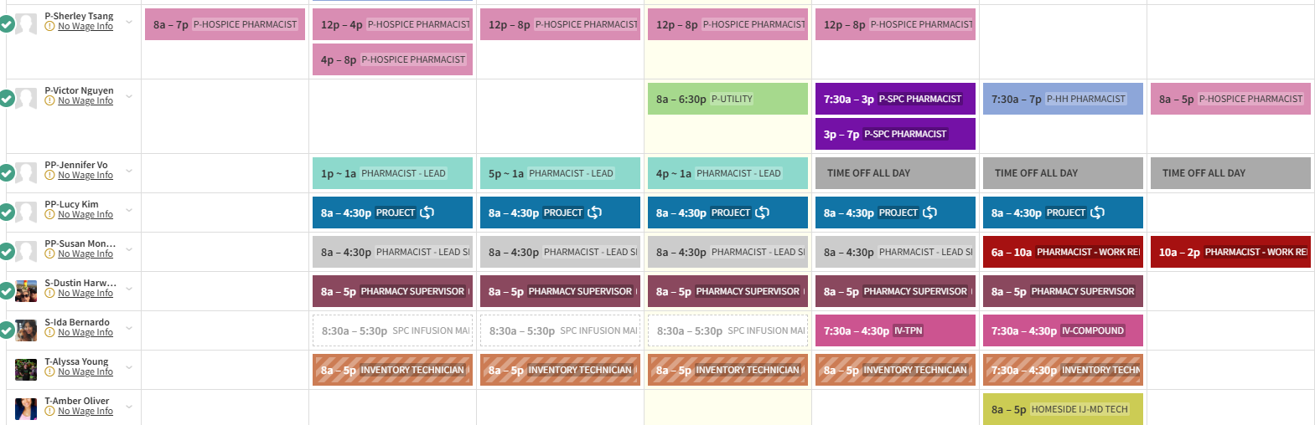
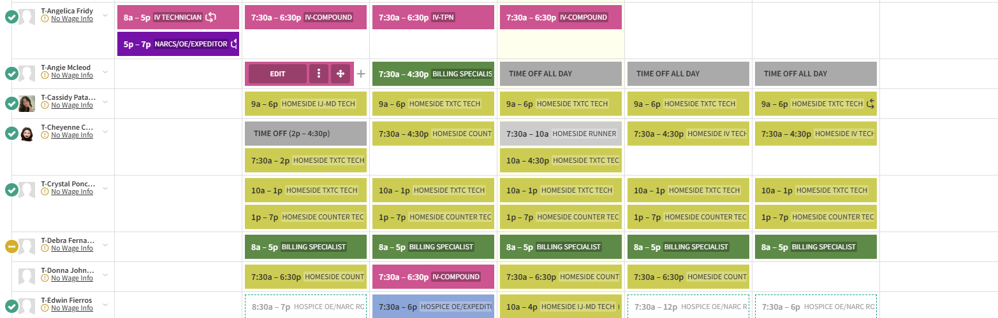
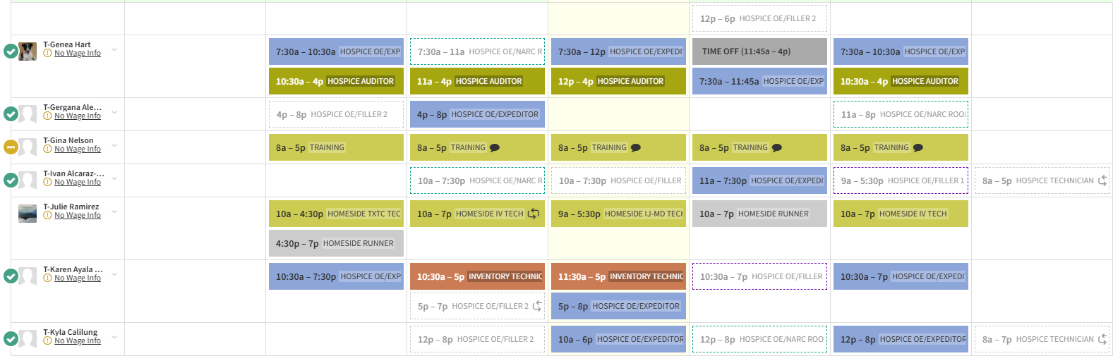
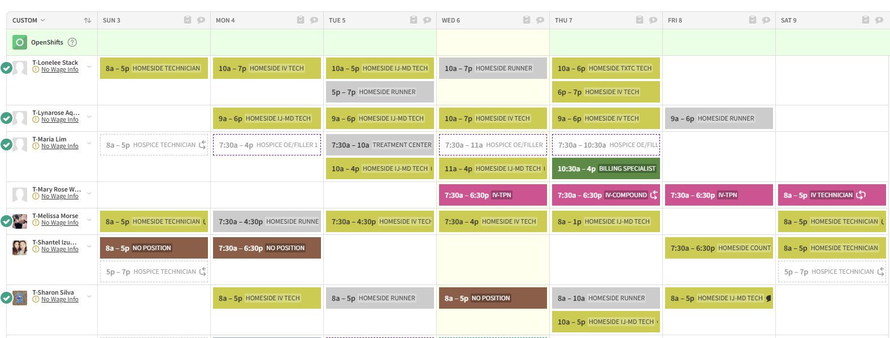
p- pharmacist
pp-manager but part of ratio if needed
s- supervisor- counted only if scheduled in “when I work” as part of workflow
SPC- infusion manager do not count for ratio
Runner- homeside runner is part of ratio
Supervisor sourcing & procurement- not part of ratio (amanda)
Billing specialist- does not count for ratio
Inventory technician- (Alyssa and karen some days) does NOT count for ratio
Hospice auditor- does not count for ratio
Training – DOES count for ratio
Project- Does NOT count for ratio (Sharon is usually the only tech that gets this) but pharmacists sometimes
Utility- is considered project and does not count as ratio
IV technician- part of ratio but in the am at 7:30-8:30 EVERY MORNING they are NOT part of ratio (not indicated on the ratio table)
Ratio table (attachment)
ON the ratio table blue means we are out of ratio
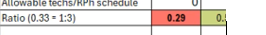 red means out of ratio
If we have a person Call out- we immediately need to change when I work to NO POSITION,
and update tardy/ Call out book
Victor, Bruce, Fariba and Juliana (all work 4 ten hour shifts)
TECH schedule- amanda and ida do hospice tech schedule and dustin does homeside tech schedule
Pharmacy Supervisor- do not count as part of ratio
Pharmacy hours 7:30 open -7close
Pharmacists in order of seniority and schedule restrictions:
1- James- m-f 8:30-5pm (every other Monday try to schedule him hospice 7:30am -4pm to keep up with clinical skill) Cant come in early Tues, we or thurs. Usually 8:30-3p then 3-5 as utility/project if possible. If possible schedule him Thursdays as CCC (all day). James- CCC until 5pm one day a week. Try to give once a month full project day

2- Juliana- 8:30am-7pm. Monday- Thursday (10 hours). Clinically strong. Not good at audits, or tickets confirmation. Juliana- Monthly needs One remote day (not part of ratio) and one consulting day, which is part of ratio (every other month she needs one remote day and TWO consulting chart days). She needs 2 extra project days to prepare for patient safety every March, June, September and December on the last week of the month.
And one hour every third Thursday of the month she should be scheduled as consulting.

3- Fariba- Tues- Friday 7:30am-6pm (ok to work weekends) (likes 4/10s)-Lives next to SMMS. Not as strong clinically, not as good at critical thinking, but good at AOB, delivery tickets audits)
4- Hiep- Tues- Saturday t-f 7:30am-3:30pm (can’t stay past 4, prefer to leave at 3:30).
Sat- 8am-7pm (okay to work Monday if needed). Good with 5 days.
Homeside- sat 8-5 then hospice 5-7pm

4- Sherley- Sunday – Thursday. Usually closes. (but has Friday sat off in exchange for sun-thurs). sun-8-7
Homeside- Sunday Homeside 8-5pm. Monday 7:30am-6pm (lucy sometimes has to move her for Sunday to Friday if needed)

5-Bruce Sunday-Wednesday (Never Friday) Any shift is okay (likes 4/10s)- (His schedu fluctuates also)

6-Victor- likes 4 10s). Doesn’t like weekends, but his senority. Wed-sat
One day a week SPC (Wednesday) -check when cleaning is (Angie makes this schedule) cleaning starts at 5 if inventory is the same day. If not then cleaning is in the morning.
Sometimes he replaces a tech in the IV room. Also Look at notes on the bottom of angies schedule. Also 8-5 Saturday hospice. Victors schedule fluctuates the most.
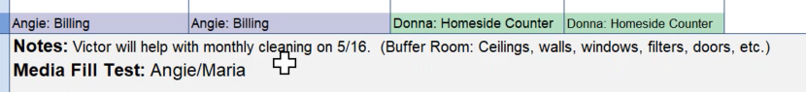

6-Ashley (graveyard pharmacist)

Maria- Perdiem (what days can you NOT work) grayed out (she cannot work)
Easier to gray so we don’t call her in

Matt- 7on 7off at hospital. Usually will commit to 3 days a month. Can only work until 6pm.

Production needs color coded in Lucys schedule:
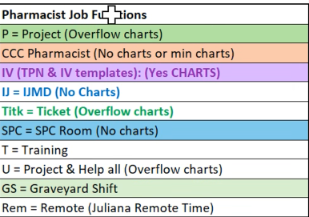

Every given day need 2.6 home side (less than 2 is very difficult)

Lucy schedule from excel:
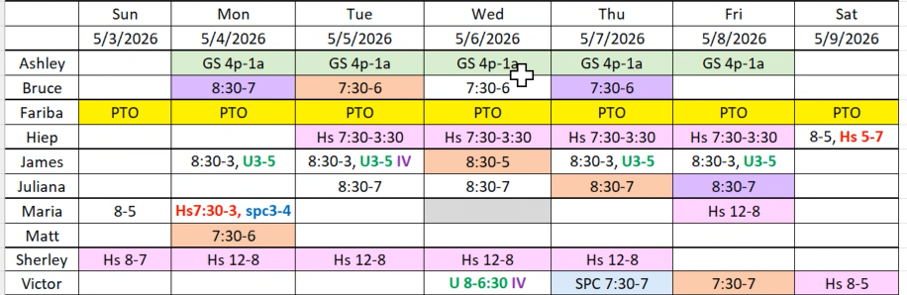

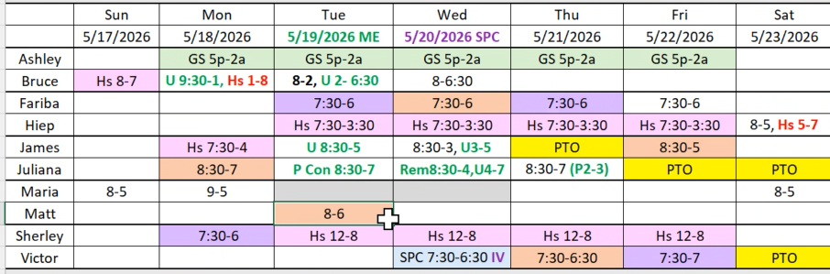

Everyday- ONE CCC RPH m-f (prefer by 8:30am)
IV RPH- Check TPN machine (must wear scrubs)
IV rph- responsible for checking template changes
Utility RPH- Assist with Project and workflow

Ashleys schedule starting 06/01/26

Lucys scheduling process:

1. Every month (one month prior to doing the schedule) Contact Maria what days can you not work (cannot exceed 960 hours)
2. Every month Matt (one month prior to doing the schedule) What days can you work (one month prior to doing the schedule) (cannot exceed 960 hours)
3. Go to when I work and fill in all PTO request days
4. Gray out the days maria cant work
5. Fill in days Matt CAN work
6. GO to SPC room schedule and plug in victor only for IV if needed (try to relieve Ida)
7. Try to plug in schedule based on regular schedule
8. QD Opening 7:30am opening for hospive and home infusion
9. Closing 7:00pm for home infusion M_F
10. Closing for 8:00pm for hospice M-F
11. Weekend/ ol 8am -5pm 8 hour (1 hour break)
12. Weekend 8am -7pm (1hr lunch) 10 hr shift
13. Lunch for all other RPH are 30 min
14. Look at ration table and make sure 4 until 6pm, 3 until 6:30 and 4 until 7pm.
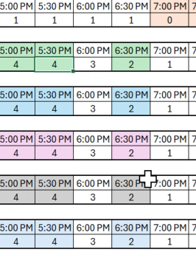
15. Go to when I work and enter the schedules based on Lucys excel table (but not publish)
16. Lucy check when I work
17. Make sure all full time get 40 hours
18. Print- and text to all rph to make sure it is ok
19. When okay- publish it in when I work and email and print and post and give to each RPH
20. Notify Jermy to update the ratio table
21. Double check ratio table
22. Make changes if needed and repost.

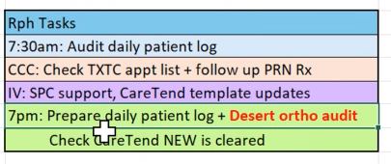
Juliana, Victor and Maria Usually the closing RPH

